Annapolis 10 Miler

Date: Sunday, August 19, 2018
Location: Annapolis, MD
Weather: Saturday: Partly Cloudy, approximately 90°F
Sunday: Cloudy, approximately 73°F
Participants: 40 Midshipmen, 1 Coach, 1 Officer Representative

Volunteering Info:
On Saturday, August 18, 2018, 26 Midshipmen participated in volunteering to set up the 43rd annual Annapolis 10 Miler race expo and finish line. Due to reform and morning briefs, the team was unable to begin volunteering until after lunch, however, the team still put forth their best effort to assist with any remaining tasks. The Annapolis 10 Miler is the first in a series of races that will prepare the marathon team for the Steamtown Marathon on Sunday, October 7, 2018.
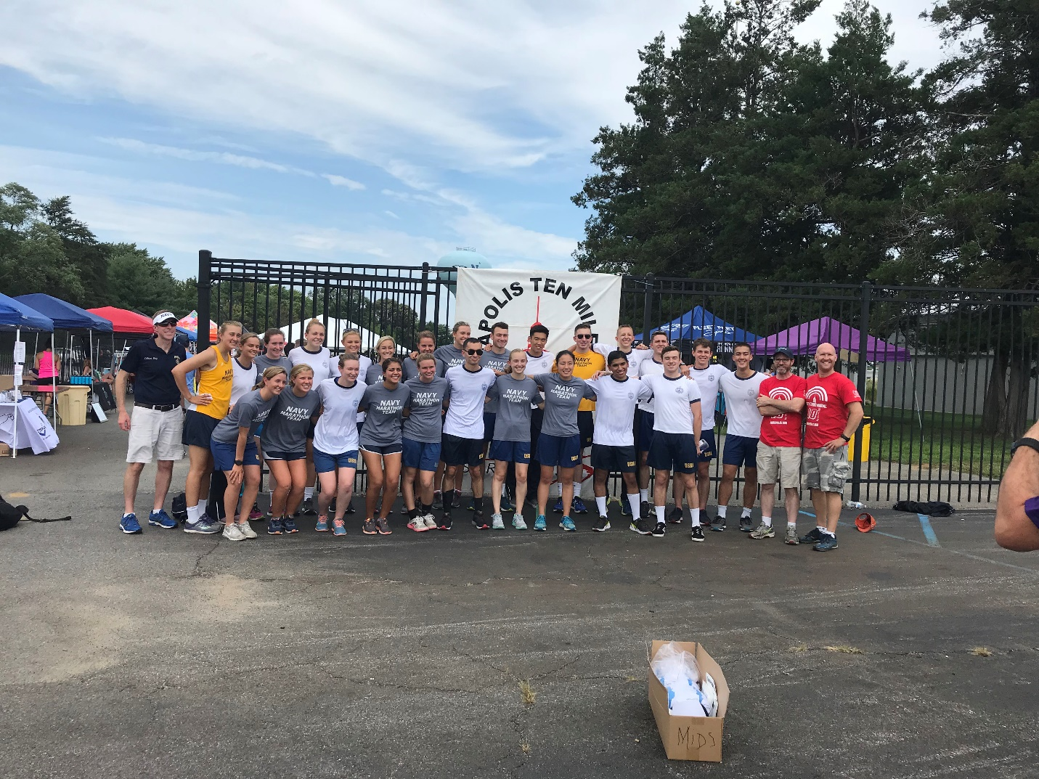
Race director Robert Cawood and Coach speak with team after volunteering.

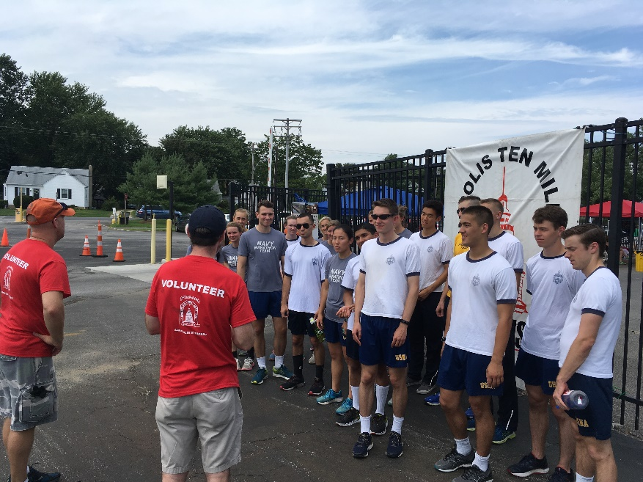
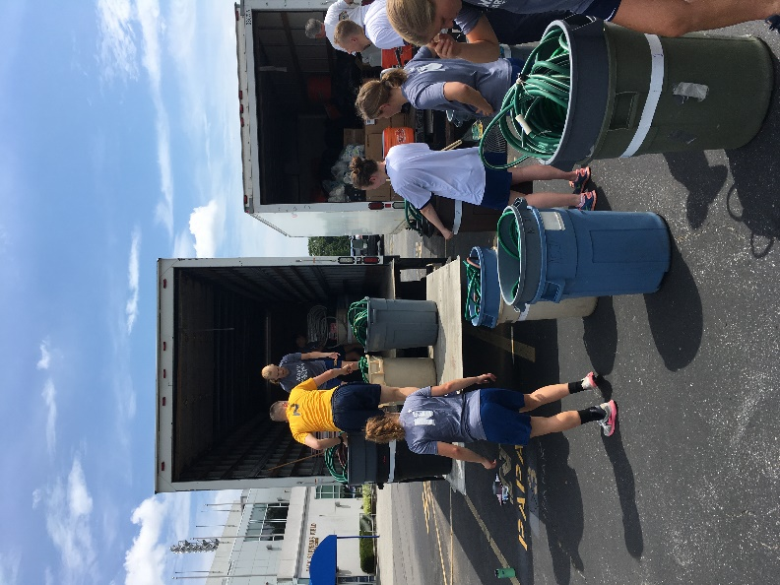
Midshipmen volunteers load houses for water stops into trucks and are addressed by one of the race coordinators.

Race Info:

On Sunday, 19 August 2018, 40 Midshipmen participated in volunteering and running the Annapolis 10 Miler. Prior to the race, Vice Admiral Carter spoke to the team to provide encouragement and motivation. The day before, the team could be seen setting up the race start and finish area. After running ten miles, the team helped break down and return all of the equipment to the race. The team was able to work together quickly and efficiently to load and unload all of the equipment, arriving back at Bancroft well before originally expected.

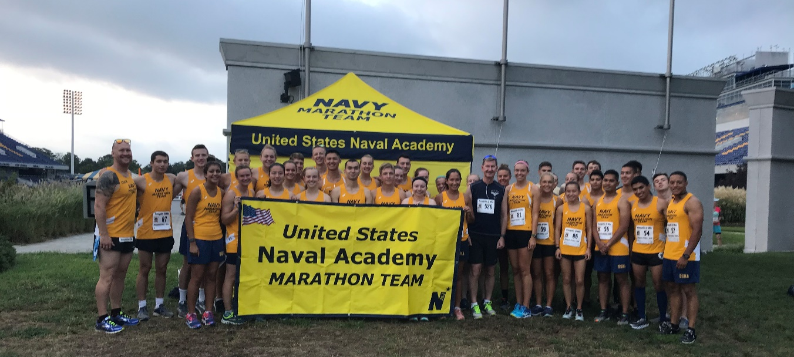
Prior to the race the Superintendent addressed the team.
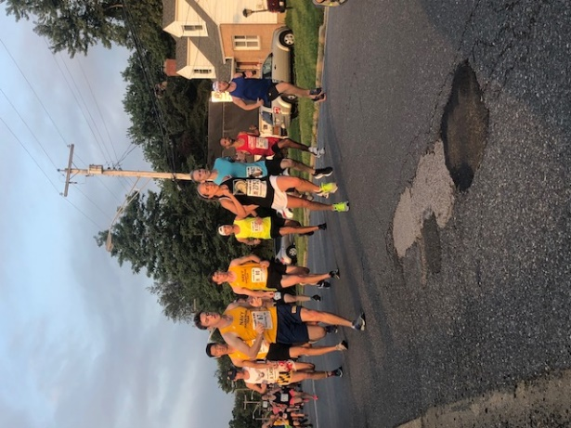
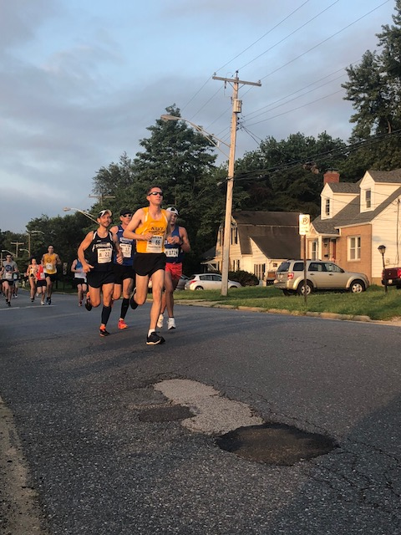
Midshipman 2/C Joe Guggenberger leads the Midshipmen 1/C Charles Oestreich, 1/C
pack. Cullen Harper, and 2/C Victor Kim work together.

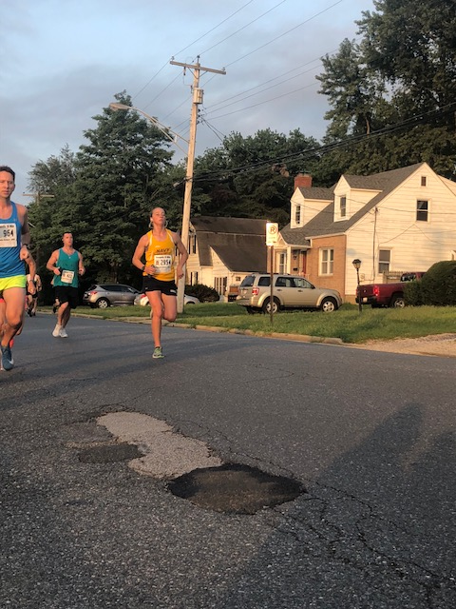

Midshipman 1/C Cassie Dooley comes in first for Navy Midshipman females and 3rd overall in the female 20-24 age group.

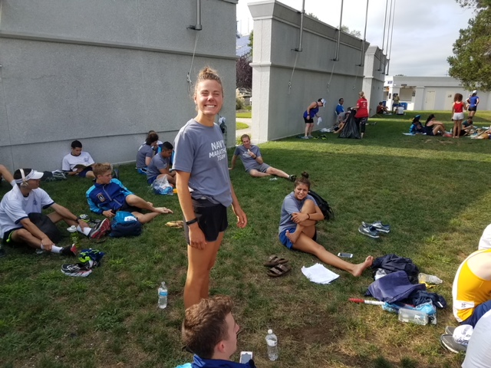
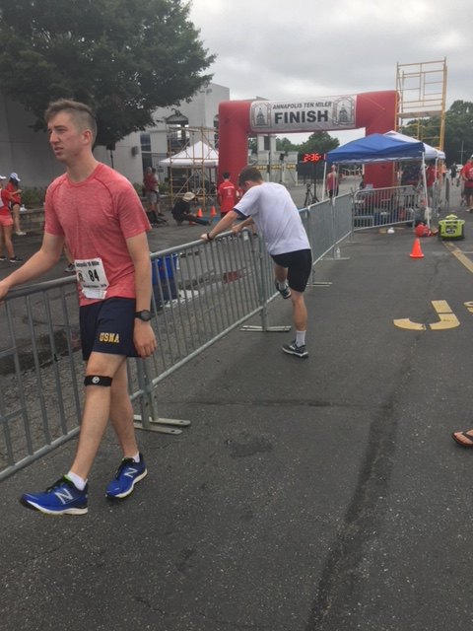
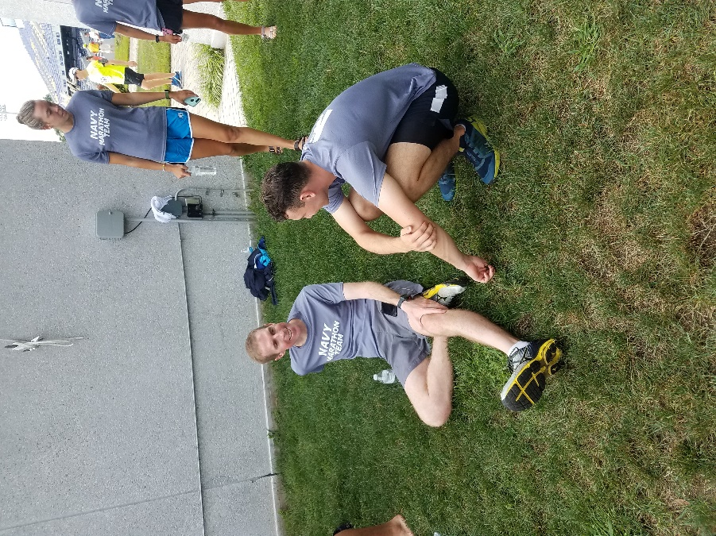
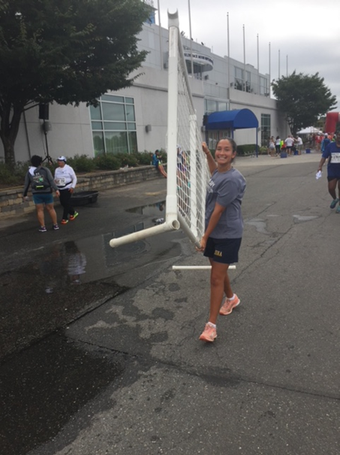
The team stretches after their race.

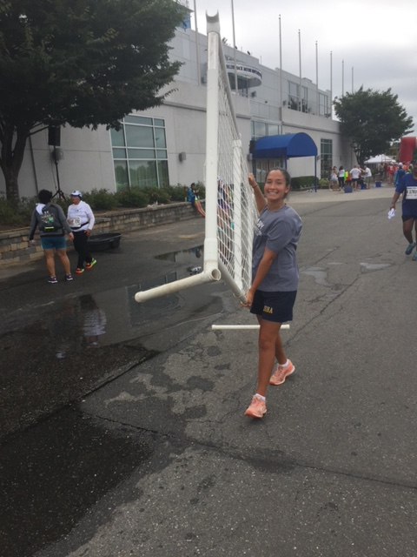
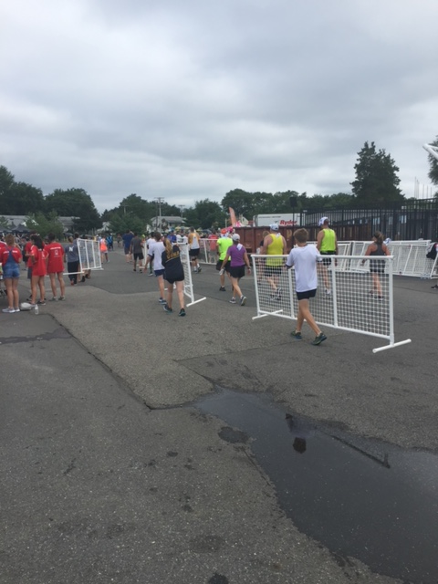
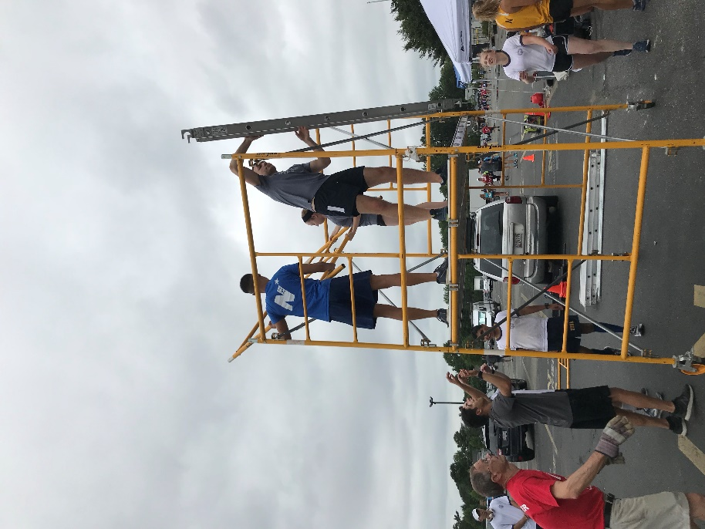
Midshipmen Volunteers take down finish line upon the completion of the race.
Results:
The team performed well at the race with Midshipman 3/C Liz Farnan placing 3rd in the female 15-19 age group and Midshipman 1/C Cassie Dooley placing 3rd in the female 20-24 age group. On the male end, Midshipman 1/C Charles Oestreich placed 3rd in the 20-24 age group. Midshipman 2/C August Roberts and the team’s OREP, LCDR Rayburg both participated as 7 minute mile pacers. Overall, several midshipmen finished in the top 100 runners and many of them achieved personal records.

Men:

Name | Expected Finish Time | Actual Finish Time | First Time Runner | PR
Oestreich, Charles | 1:10:00 | 1:05:10 | * | *
Guggenberger, Joseph | 1:10:00 | 1:05:30 | * | *
Kim, Victor | 1:20:00 | 1:05:50
Anderson, Tristan | 1:15:00 | 1:06:36 | * | *
Fish, Brendan | 1:10:00 | 1:07:02 |  | *
Castillo, Raul | 1:08:00 | 1:07:21 | * | *
Brakey, Chris | 1:20:00 | 1:09:00
Harper, Cullen | 1:10:00 | 1:10:30 | * | *
Yu, Garret | 1:20:00 | 1:10:33 |  | *
Brown, Jamel | 1:15:00 | 1:10:58 |  | *
Carrillo, Victor | 1:20:00 | 1:14:25 | * | *
Swift, Grant | 1:15:00 | 1:16:33 | * | *
Grammer, Justus | 1:20:00 | 1:16:37 | * | *
Sellock, Ethan | 1:17:00 | 1:17:00 | * | *
Gerrety, Raymond | 1:12:00 | 1:17:00
De La Pena, Benito | 1:20:00 | 1:17:07 | * | *
Fitri Bin Mohd Idris, Mohamad | 1:30:00 | 1:22:00
Lee, Andrew | 1:25:00 | 1:27:00
Roberts, August | 1:10:00 | 1:09:40

Women:

Name | Expected Finish Time | Actual Finish Time | First Time Runner | PR
Dooley, Cassie | 1:13:00 | 1:08:30
Lane, Grace | 1:25:00 | 1:10:55 |  | *
Roxbury, Niki | 1:25:00 | 1:11:24 |  | *
Harvey, Zibby | 1:25:00 | 1:20:14 | * | *
Farnan, Elizabeth | 1:20:00 | 1:21:15 | * | *
LaVeck, Victoria | 1:25:00 | 1:21:35 | * | *
O'Neil, Madeleine | 1:20:00 | 1:22:34
Walha, Anmol | 1:25:00 | 1:22:34
Buzzard, Caroline | 1:30:00 | 1:23:00 | * | *
Bryan, Chloe | 1:20:00 | 1:24:00 | * | *
Phillips, Alana | 1:20:00 | 1:24:25 | * | *
Good, Kendal | 1:30:00 | 1:26:00
MacDonald, Julia | 1:27:00 | 1:26:00
Maguire, Jamie | 1:30:00 | 1:26:00 | * | *
Sydney Hirokawa | 1:30:00 | 1:26:30 |  | *
Johnson, Kyra | 1:30:00 | 1:27:00 | * | *
McFarland, Julia | 1:30:00 | 1:27:00 |  | *
McGinnis, Jordan | 1:30:00 | 1:27:00 | * | *
Robinson, Cara | 1:40:00 | 1:28:01
Lemek, Natalie | 1:30:00 | 1:28:12
Martinez, Claire | 1:30:00 | 1:30:30 | * | *

Coaches:

Name | Actual Finish Time | PR
Nate Nudelman (Coach) | 1:23:02
Casey Rayburg (OREP) | 1:09:45

After Action Report completed by Midn 2/C Anmol Walha

